**WORKSHEET 1**

**Name :- Rahul maurya UID:- 20BCS7260**

**Subject :- python lab class:- 716 A**

**Question :-**

1. Write a  program c to enter two numbers and perform all arithmetic operations.
2. Write a  program to enter marks of five subjects and calculate total, average and percentage.
3. Write a  program to enter length in centimeter and convert it into meter and kilometer, and also convert the same into Equivalents

**Code :-**

1

n=float(input("enter first number:"))

m=float(input("enter second number:"))

print("addition",n+m)

print("division",n/m)

print("subtraction",n-m)

print("multiplication",n*m)

2nd

a=int(input("subject 1:"))

b=int(input("subject 2:"))

c=int(input("subject 3:"))

d=int(input("subject 4:"))

e=int(input("subject 5:"))

f=int(input("OutOff :"))

sum=a+b+c+d+e

print("Total marks",sum)

print("Average marks",sum/5)

print("Percentage:",(sum/500)*100,"%")

3rd

n=float(input("Enter length in centimeter:"))

print("lenght in meters:",n/100)

print("length in kilometers:",n/100000)

**OUTPUT:-**

**First**

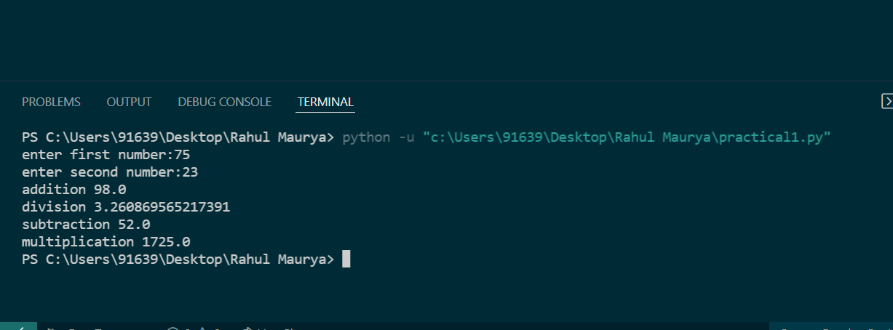

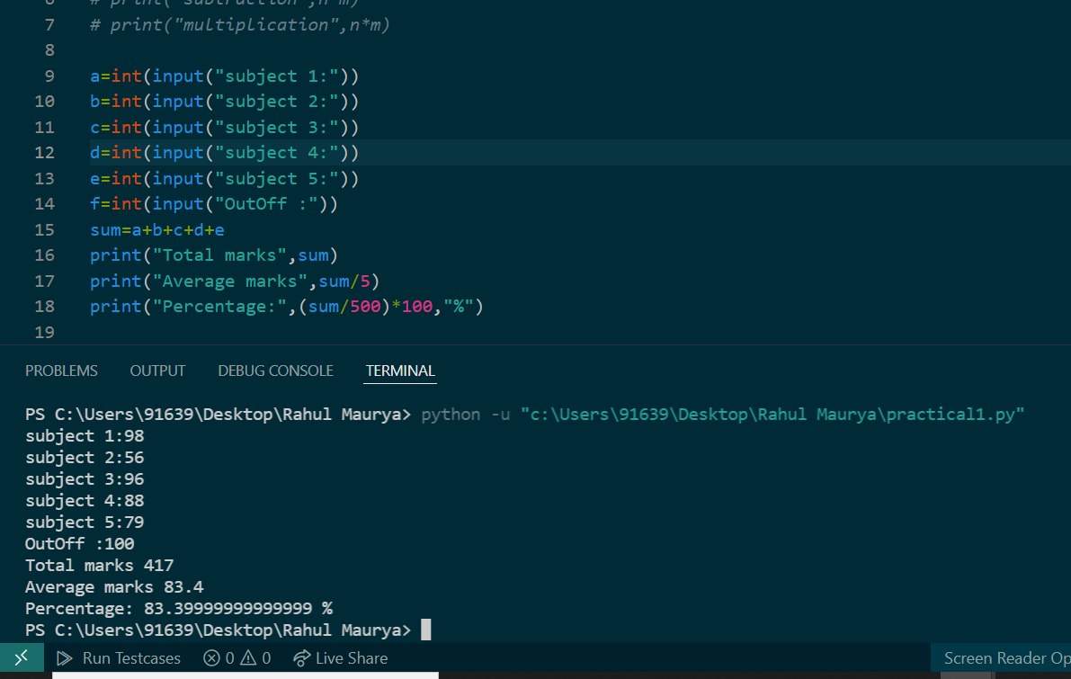**second**

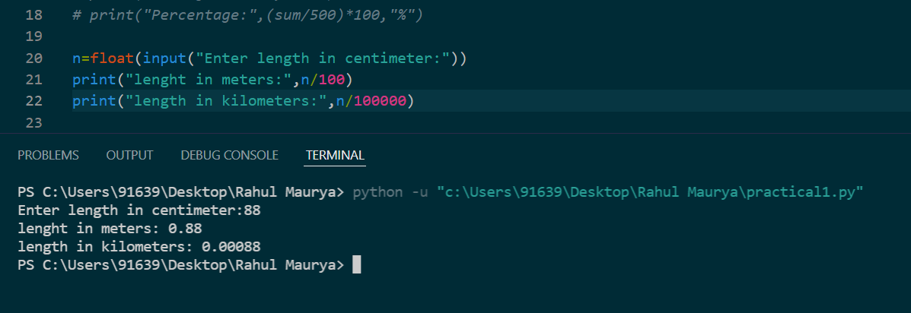Third

# Learning outcomes (What I have learnt):

## Learnt about different types of data types

## Learnt about different types of operators

1. Learnt about ethernet cables
2. Learnt how to make an ethernet connection possible

**Evaluation Grid (To be created as per the SOP and Assessment guidelines by the faculty):**

|  |  |  |  |
| --- | --- | --- | --- |
| Sr. No. | Parameters | Marks Obtained | Maximum Marks |
| 1. |  |  |  |
| 2. |  |  |  |
| 3. |  |  |  |
|  |  |  |  |